**Opening question to be read exactly:**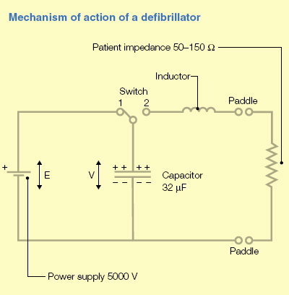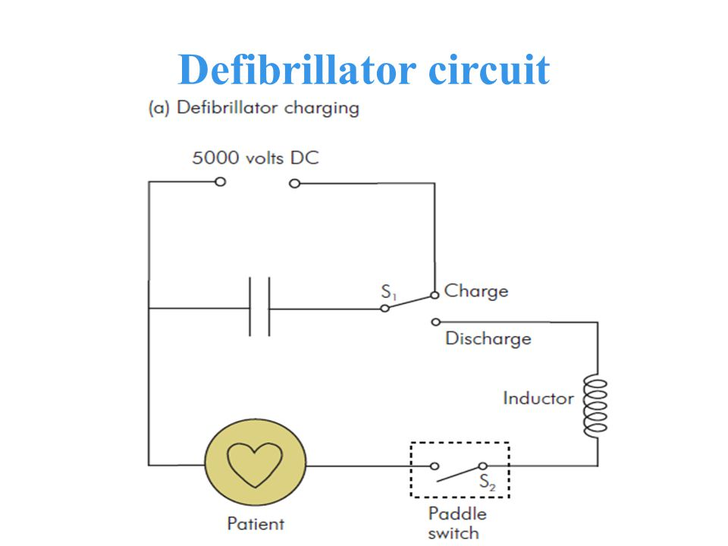

**“What is a defibrillator?”**

It is a piece of electrical equipment that is used to treat VF/VT and for electrical cardioversion.

**What are the components of a defibrillator?**

It is made up of 2 separate circuits, one for charging and one for discharging.

There is a switch between the 2 circuits. there is another switch in the discharging circuit to initiate delivery of the charge.

The **charging circuit** contains a power source (**battery** or mains), **a rectifier ( or diode) to convert AC to DC (if it is mains supply)** and a **capacitor** to store the electrical charge.

The potential difference supplied from the power source to the circuit is 5000 volts DC. Once the capacitor is full charged, a switch then moves to complete the discharging circuit.

The **discharging circuit** contains the **capacitor**, **an inductor and another switch**. The patient completes the circuit when the 2 paddles are applied to the chest. When the paddles are activated the stored charge is released.

**What is capacitance?**

it is a measure of the ability of an object to store electrical charge.

It is defined as the charge stored by an object per voltage difference across it.

SI unit is Farad.

**What is a Farad?**

it is the capacity to store 1 coulomb of charge, when a potential difference of 1 volt is applied.

Capacitance(Farads) = Charge (Coulombs)/ Potential Difference (Volts)

**What is a Capacitor?**

It is an electrical component made up of 2 conducting plates that are separated by an insulator.

It will become charged when p.d exists across it but it will not allow DC to flow.

A.C. induces repeated charging and discharging of a capacitor.

It is an essential part of a defibrillator.

**How do you calculate the stored energy in a capacitor?**

E= 1/2 x Q X V

Q= Coulombs V = Voltage

**Can you give an example of interference caused by capacitance in the operating theatre?**

It may cause interference on the ECG trace due to the AC passing from the operating theatre light to the patient. This is because the light acts as one plate of the capacitor and the patient as the other. The air gap between the 2 is the insulator. A small amount of 50 Hz AC passes from the lamp to the patient resulting in ECG interference.

**What is Inductance?**

Defined as the capacity for an electromotive force to be induced in an electrical circuit. It achieves this by changing the current flowing in the circuit or in a neighbouring circuit. Inductance is therefore based on Electromagnetic forces and can also lead to interference in biological electrical signals.

**What is an inductor? Give an example**

It is an electrical component that induces an electromotive force in an electrical circuit.

It achieves this by changing the current flowing in the circuit. It is typically a coil of wire, as indicated in the electrical symbol.

**What is the function of the inductor in a defibrillator circuit?**

Opposes a sudden change in current flow and slows down the rapid discharge from the capacitor. The inductor therefore ensures that the electrical pulse delivered to the patient has optimum shape and duration to reduce the likelihood of burns and for effective defibrillation. The inductor also absorbs some of the electrical charge, so the amount of delivered charge is always less than the stored charge.

**What is an Insulator?**

a substance which electrons are firmly bound together and are not able to move.

Insulators do not conduct electricity.

**What is a Conductor?**

a material in which the electrons are loosely bound together and can move through the material under the influence of an electric potential e.g metals, carbon, saline